Firmware Analyze

- Environment
  - VMware Ubuntu 24.04.2

- Fireware download
  - URL:www.tp-link.com/pk/support/download/tl-wr845n/#Firmware
  - Fireware model: TP-Link TL-WR845N v4
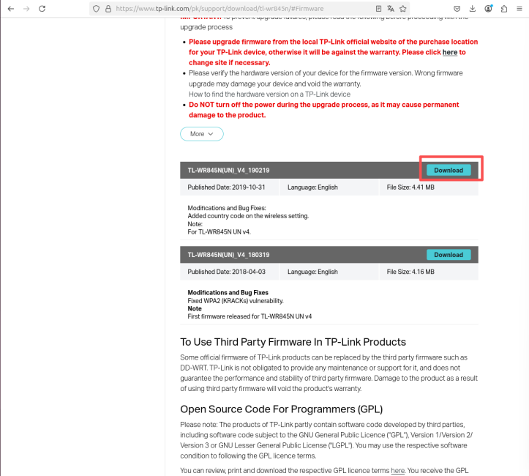

- Firmware Structure Analysis
  - Run: binwalk TL-WR845Nv4_UN_0.9.1_3.16_up_boot[190219-rel55060].bin
  - The output shows:
    - U-Boot boot information
    - LZMA compressed segment
    - SquashFS file system

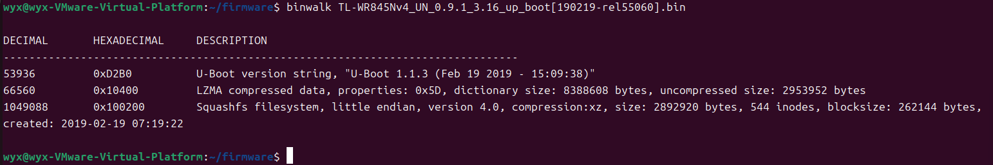

- File system extraction
  - Run: binwalk -e TL-WR845Nv4_UN_0.9.1_3.16_up_boot[190219-rel55060].bin
  - Directory successfully extracted:
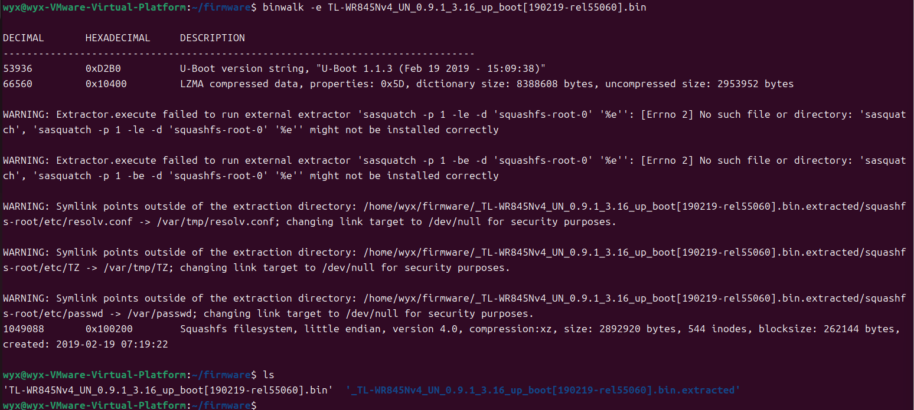
- File system content analysis
  - Enter the file system: cd squashfs-root
  - Visible structure: bin dev etc lib linuxrc mnt proc sbin usr var web
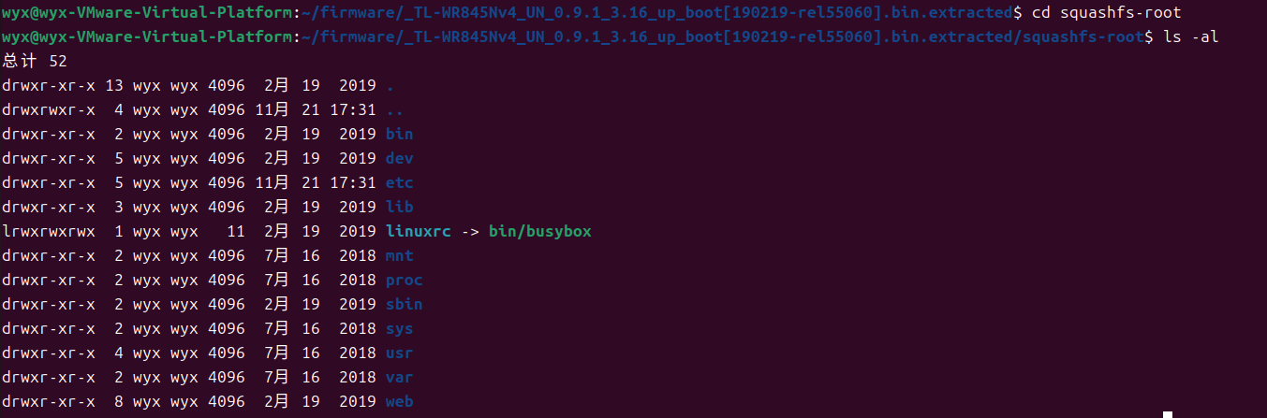
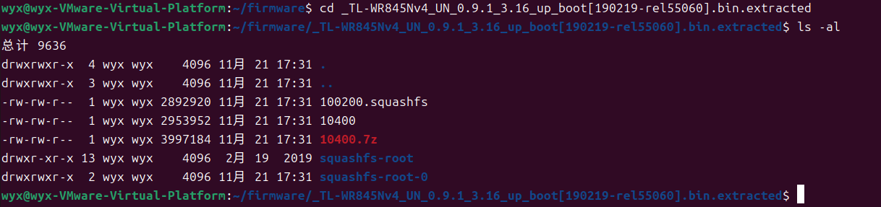

- Hardcoded password lookup
  - Enter the etc folder
  - The passwd file can be found, but it points to null
  - The passwd.bak file was found
  - Use cat to view
  - Obtain administrator account and password
    - Administrator account: admin
    - Password: $1$5iC.dUsGpxNNJGeOm1dFio/
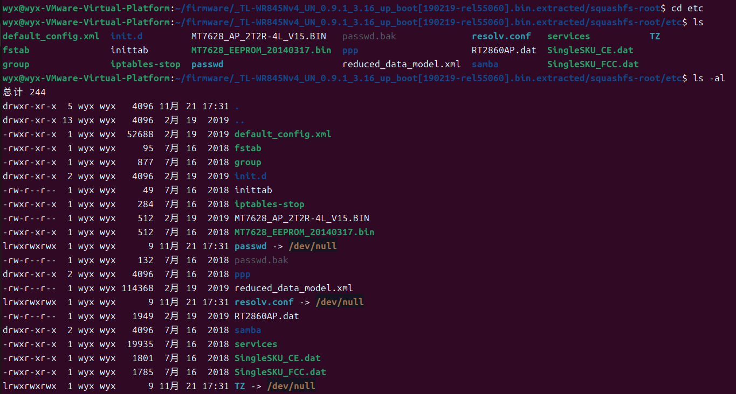
- Startup script analysis
  - View the startup process(rcS)
  - Get fragment: cp -p /etc/passwd.bak /var/passwd
    - This means that the system automatically restores the hard-coded password every time it starts up, and the password cannot be changed through normal means.
    - And it can be confirmed that the previous password was indeed the administrator password.

